**Requirement Gathering and Analysis Phase**

**Data Flow Diagram & User Stories**

| Date | 04/07/2024 |
| --- | --- |
| Team ID | SWTID1719925692 |
| Project Name | Project - Book-Store |
| Maximum Marks |  |

**Data Flow Diagrams:**

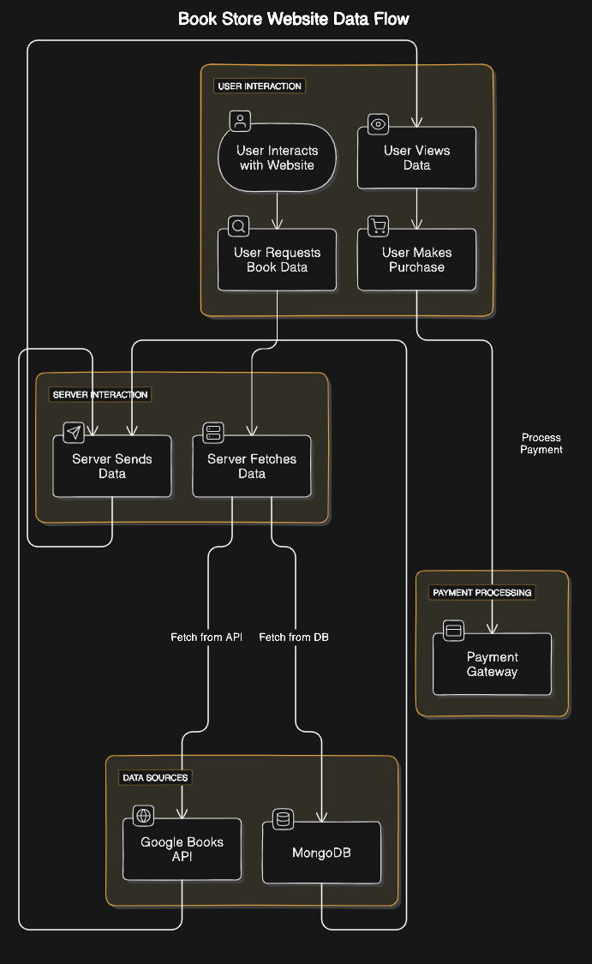

**User Stories**

| **User Type** | **Functional Requirement (Epic)** | **User Story Number** | **User Story / Task** | **Acceptance criteria** | **Priority** | **Release** |
| --- | --- | --- | --- | --- | --- | --- |
| Customer (Mobile user) | Registration | USN-1 | As a user, I can register for the application by entering my email, password, and confirming my password. | I can access my account / dashboard | High | Sprint-1 |
|  | Confirmation | USN-2 | As a user, I will receive confirmation email once I have registered for the application | I can receive confirmation email & click confirm | High | Sprint-1 |
|  | Registration | USN-3 | As a user, I can register for the application through Gmail | I can register & access the dashboard with Gmail Login | Low | Sprint-2 |
|  | Login | USN-4 | As a user, I can log into the application by entering email & password | customer can login and enter the website | Medium | Sprint-1 |
|  | Dashboard | USN-5 | As a user i can edit my profile information | customer can edit and save changes to their profile details | Low | Sprint-2 |
| Customer (Web user) | Cart page | USN-6 | As a web user I should be able to add my items whenever I want and the information should be accessible through the cart | users should be able successfully add the desired items and other details in the cart | High | Sprint -1 |
|  | Search Bar | USN-7 | As a user I should be able search every kind of book I wanna get to know and the sellable details which makes the decision to buy | User should get the relevant search results when the applicable prompt is applied | Medium | Sprint -4 |
|  | Orders page | USN- 8 | As a user I should be able get the order history track and status of the order so that necessary details will be checked accordingly | The information about status and and other order details should be viewable at right time | medium | Sprint-2 |
| Customer Care Executive | User Management | USN-9 | As a care executive i can overview all the user details and manage it | Care executive can view user details and manage their account details | Medium | Sprint-1 |
|  | Customer Support | USN-10 | As a care executive i can check if any user faces any issues and respond to their queries | Care executive can view the queries and respond to the users and help in resolving their issue | High | Sprint-1 |
| Administrator | Content Management | USN-11 | As an administrator i can add,edit,remove books from the books section | Administrator can manage all the book detail data and perform any operations | High | Sprint- 2 |
|  | User Roles | USN-12 | As an administrator i can assign roles for user (i.e) admin/moderator | Administrator can assign and manage the user roles based on their login info | High | Sprint-2 |